# **Computer Hardware Identification**

**Date:**

**Group Name:**

**Group Members (2 Max):**

In this activity, in groups of 2, you will be taking a computer apart. Using a working computer and a phone, take pictures of the components and enter a description of the component and what it does. If the computer that is being dissected does not have the component, then getting an image from the internet is acceptable. Identify and describe the following computer components:

1. Case
2. Image:

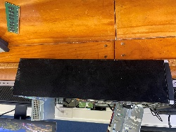

* + Description: enclosure that contains most of the hardware of a personal computer.
  + Function:  a way to physically mount and contain all the actual components inside a computer,

1. Motherboard
   * Image:
   * 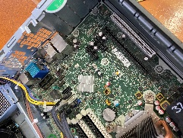
   * Description: A motherboard is the main printed circuit board (PCB) in a computer
   * Function: The motherboard is the backbone that ties the computer's components together at one spot and allows them to talk to each other.
   * GPU
   * Image: A picture containing electronics, electronic component, circuit component, circuit

     Description automatically generated
   * Description:  a specialized processor originally designed to accelerate graphics rendering
   * Function: to accelerate graphics rendering.
2. RAM
   * Image:
   * A picture containing circuit, electronics

     Description automatically generated
   * Description: RAM is a common computing acronym that stands for random-access memory.
   * Function: RAM is a temporary memory bank where your computer stores data it needs to retrieve quickly
3. Storage Device
   * SSD vs HDD
4. Cooling

Image:

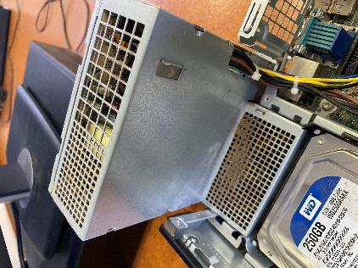

* + Description: Cooling is removal of heat, usually resulting in a lower temperature and/or phase change
  + Function: to reduce the ambient temperature within the case of a computer, such as by exhausting hot air, or to cool a single component or small area (spot cooling)
  + CPU
    1. Image:
    2. 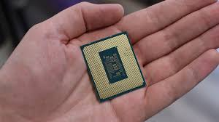
    3. Description: The component of a computer system that controls the interpretation and execution of instructions
    4. Function: The CPU is the brain of a computer, containing all the circuitry needed to process input, store data, and output results
  + Chassis
    1. Image: A picture containing electronics, machine, electrical wiring, computer component

       Description automatically generateds
    2. Description:  is another word for a computer case, aka tower.
    3. Function: is the frame that houses the internal components of a computer,

1. PSU (Power Supply Unit)
   * Image: A picture containing electronics, electrical wiring, cable, electronic engineering

     Description automatically generated
   * Description: (PSU) is a hardware device that converts AC electricity into DC electricity and then distributes it to the rest of the
   * Function:  (PSU) converts mains AC to low-voltage regulated DC power for the internal components of a computer.
2. Monitor
   * Image: 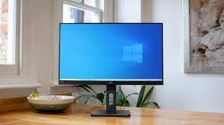
   * Description:
   * Function:  displays information in pictorial or textual form.
3. Mouse
   * Image
   * A black speaker on a wood surface

     Description automatically generated with medium confidence
   * Description: A mouse is a small device that a computer user pushes across a desk surface in order to point to a place on a display screen and to select one or more actions to take from that position.
   * Function: A mouse typically controls the motion of a pointer in two dimensions in a graphical user interface (GUI)
4. Keyboard
   * Image:
   * 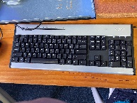
   * Description A keyboard is for putting information including letters, words and numbers into your computer
   * Function: A keyboard's primary function is to act as an input device